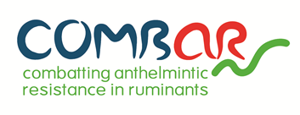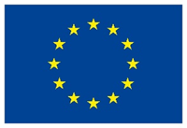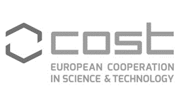

4th COMBAR joint Working Group meeting
“Anthelmintic Resistance in Ruminants: from Research to Recommendations”
9-10 December 2020
Online event

INSTRUCTIONS FOR ABSTRACTS

Participants in the COMBAR meeting are invited to submit their abstracts for oral or poster presentations. The deadline for submitting abstracts 15th of October 2020. The abstracts should be submitted via e-mail in the appropriate format:
- Abstract: Must be in English with a maximum extension of 250 words.
- Font sizes: Follow the template sizes shown below (Font “Candara, size 10”)
- Authors: Underline presenter. Affiliation of all authors and e-mail address of the presenting author should be included. By submitting, authors give permission to publish their contact details in the abstract book.
- Registration: Presenters are expected to register and attend the event.
- Notification: If the abstract is accepted for presentation, the presenter will be notified by the 15th^{th} of November, 2020.
Abstracts should be submitted via e-mail: costcombar@yahoo.com

Title of the abstract

Authors and Affiliations

Text (maximum extension of 250 words)

Presenter: | Preferred format
Affiliation:  Email:  COMBAR Working Group (1, 2 or 3): | Oral: | Poster:

CS Abstracts

